**201533661 이승수’s data science lab3**

**Problem1. With given datasetD of 100 records, find outliers and set BMI into 0, 5.**

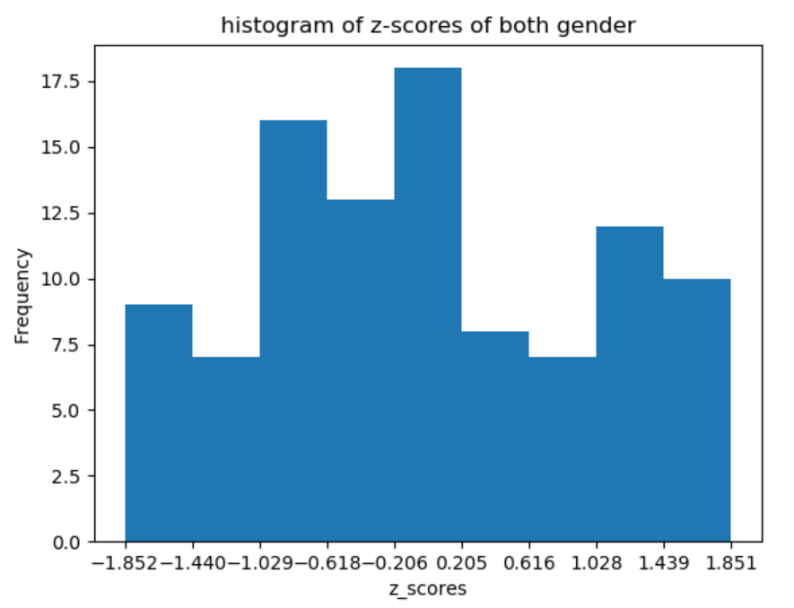

\***Find outliers from female gender.**

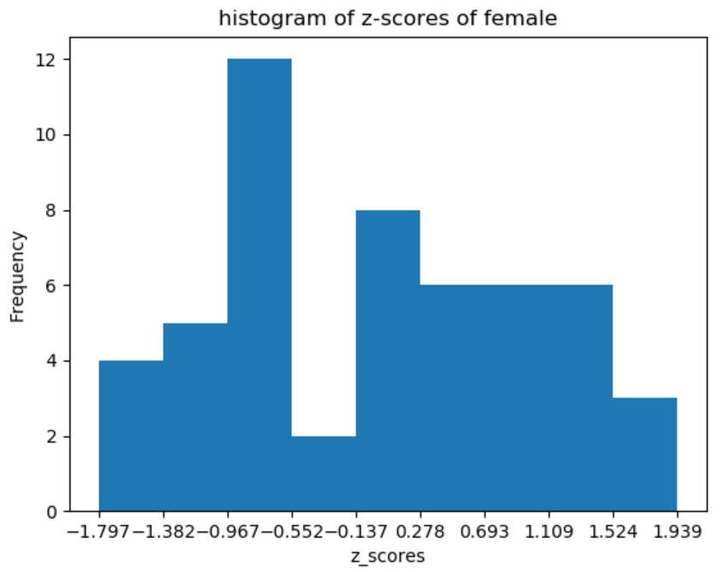

**\*Find outliers from male gender.**

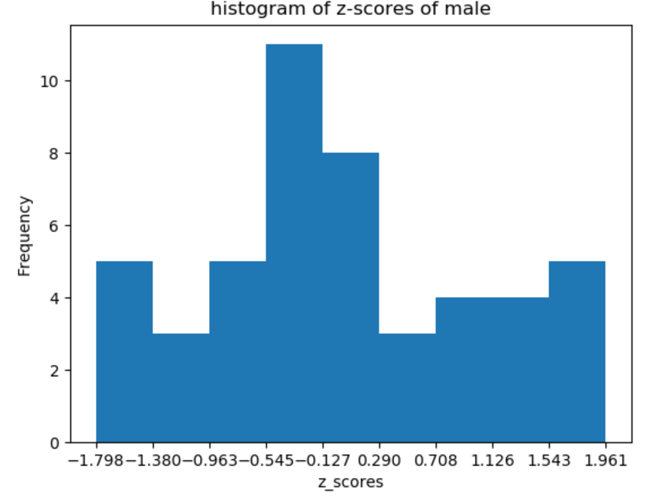

**Problem 2. Solve previous example(estimate dirty datas with linear regression) using pandas and scikit-learn with mean values estimation and compare it with previous.**

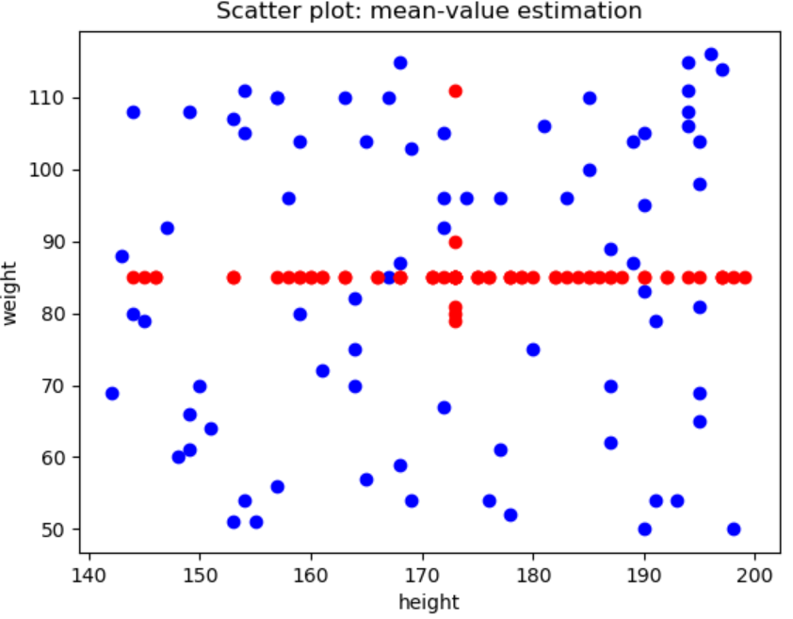

At mean value estimation, estimated scatter plots make horizontal line so linear regression looks more accurate.